California State University Fullerton

CPSC 462



Object Oriented Software Design

Vision and Business Case

for the

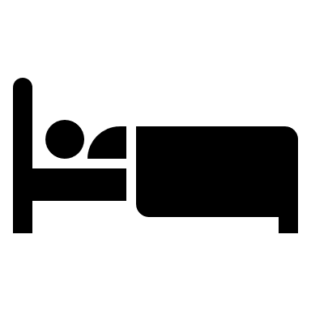

Hotel Room Reservation

System

|  |
| --- |
| **Allen Rivas** |
| Chief Technical Officer (CTO) |
| [allen.rrivas30@csu.fullerton.edu](mailto:allen.rrivas30@csu.fullerton.edu) |

Revision History:

| Version | Date | Summary of Changes | Author |
| --- | --- | --- | --- |
| 1.0 | March 23, 2021 | * First draft. To be refined primarily during the elaboration phase. | Allen Rivas |
| 1.1 | April 27, 2021 | * Updated this draft with a new logo, more information in the executive summary, stakeholder, and iteration plan. Updated with a new system context diagram. | Allen Rivas |
| 1.2 | May 16, 2021 | * Updated this draft by adding change bars to indicate the changes that have been made. | Allen Rivas |

Table of Contents

1 Executive Summary 1

2 Positioning 1

2.1 Business Opportunity 1

2.2 Problem Statement 1

2.3 Product Position Statement 1

2.4 Alternates and Competition 2

3 Stakeholder Descriptions 2

3.1 Market Demographics 2

3.2 Non-User Summary 2

3.2.1 Director 2

3.2.2 System Administrator 2

3.3 User Summary 2

3.3.1 Guest 2

3.3.2 Receptionist 2

3.4 Key High-Level Goals and Problems of Stakeholders 2

3.5 User-level Goals 4

4 Product Overview 5

4.1 Product Perspective 5

4.2 System context Diagram 5

5 Summary of Benefits 5

6 Summary of System Features 5

7 Investment Summary 5

7.1 Cost Summary 5

7.2 Pricing Summary 6

7.3 Schedule Summary 6

7.3.1 Iteration Plan 6

8 Assumptions and Dependencies 6

9 Go / No-Go Decision 6

# Executive Summary

Hotel Room Reservation system is a software that allows hotel guests, receptionists, and administrators to make reservations for rooms and other amenities. The overall goal of this software is to make a system that is flexible and reliable that can benefit users. The software should be able to handle any type of risk, from the loss of power or an overload of users trying to make a reservation. We instead to sell our product to developing hotels, but also be our idea of flexibility for this software is to have the capability of integrating it into a system that has already been implemented by the existing hotels. Our market target would be hotels that developing itself in the current market, but also hotels that are already well established, at a reasonable price. Prices will be flexible, with either installments if the companies want to buy the software or there will also be a subscription plan with monthly payments. There are other competitors out there that have the somewhat the same production idea but is seems like their target competitors are motels or small companies, their software is built in a short-term usage and, they seem uncappable of integrating into existing systems. When our software is production ready, we think that we can be above this area of the market and make an impact. We are planning on releasing our hotel room reservation system within the next nine months, which involved the developing, testing, and pre-updates before the software will finally make it, into the market. Once the product is out into the market, we will have constant updates every month to fix bugs and other issues that we will encounter, so we can provide the most reliable software on the market.

# Positioning

## Business Opportunity

The existing hotel reservation systems are capable, but our system is adaptable and can be easily integrated into an existing system. We see it as the perfect time to dive into the market and possibly provide a hotel room reservation system not only for one hotel company, but for whoever will be interested in out reliable product. It can be easily integrated into third-party systems that are designed to help users make reservations for hotel rooms. It can work in online environment, making it easier to make reservations from anywhere with the access of internet. This product it able to be integrated into this market and could lead to total flexibility with our customers.

## Problem Statement

General hotel room reservation system there are already many available reservation software, but they are not flexible, and many are not specifically made to be integrated into several systems. The problem is that it can lead into processing failure as it is possible for it not to match with the system, making it hard for users to make a reservation or edit it. This affects hotel customer, clerks, and the system administrator.

We are trying to build a hotel room reservation system with extremely great improvements and reliability. We believe that with these improvements on the reservation system it will allow guest, customer, or any user to enjoy the system to the fullest.

## Product Position Statement

The overall system is made for users are interested in making a reservation for a hotel room. This involves the hotel customers and clerks. Also, the system administrators who are the users that can update the information that is being inputted from the system. Hotel customers involvement is to overall be capable of making a hotel room reservation of their liking, with other added features. The hotel clerks can do the same as the hotel customer if it is requested from them. This differentiates from the competition in the sense that it can be integrated into a hotels already existing reservation system which in the long run can develop outwards and each hotel system can be the same and made easy for customers to make reservations.

## Alternates and Competition

The competition that is laid out in front of us are companies like Hotel Trivago or similar companies that can compare prices of nearby hotels and finding the one that is of good price for the customer. They also have its downfall which it is not made for other users apart from the hotel customer. Other competition that are out there are other hotel companies that already have an integrated system that can make room reservation for their guest or through a receptionist. We believe that we can provide a hotel room reservation system that can be integrated with an already existing one that can make the system more efficient, user-friendly, and reliable.

# Stakeholder Descriptions

## Market Demographics

This hotel room reservation system market demographics are for customers that are interested in making reservations through an online system. This puts the edge over certain hotels that do not have this type of system already implemented as they might not have the resource for it. If there are hotel companies that do not have this type of system, then it can be available to them also under certain circumstances.

## Non-User Summary

### Director

Their overall goal us to look over the direction that the hotel is going. They have access to the data in the hotel room reservation system as they overlook that area to make decisions. The decisions are pathways that can affect the hotels reservations.

### System Administrator

Their overall goal is to look over operations of the hotel room reservation system. They can make update to the information in the system from all the hotel guest. They have the utmost access to all the data that is about the specific hotel.

## User Summary

### Guest

Their overall goal is to make a room reservation using the hotel room reservation system. They should be able to make updates the reservation that they have made and should be able to make the payments required to reserve the room.

### Receptionist

Their overall goal is to process whatever the hotel customer has requested. They should be able to make room reservations and can also update the reservation. Capable of also processing the payment that has been made by the hotel customer.

## Key High-Level Goals and Problems of Stakeholders

A one-day demonstration with industry experts and other stakeholders, and with surveys at other hotels led to the following goals and problems:

| Stakeholder | High-Level Goal | Priority | Issues / Problems | Interests / Solutions |
| --- | --- | --- | --- | --- |
| Director | Fast, robust hotel room reservation system | High | Current system is slow and take many steps to perform the most of basic of functions when they are in use. This leads to frustration and deviation from use because it is too complicated. This leads to a loss of reservations. | Updates the hotel room reservation system to have consistency throughout the multiple functions, so the guests are not confused when navigating.  Implement notifications when the system has been updated, showing guests what was changed and what this will do for their change. |
| System Administrator | Fast, robust hotel room reservation system | High | Increase speed/throughput as load increases.  Lack of updates on existing system. This leads to inaccurate information and a less functional system. Leads to loss of reservations and loss of sales  System is unable to be customized or add new terminals for more versatility. | Existing hotel room reservation systems provide the most basic needs, but do not address current and future issues.  Implementing updates on a regular basis to align with current trends of other competing systems. Try to identify where these competing systems fall short and implement that solution into our updates. |
|  |  |  |  |  |
| Guest | Fast, robust hotel room reservation system that is capable of reserving and updating a reservation. | High | Competing hotel room reservation systems require the guests to usually call in to confirm the changes, even after they made the changes on the system. This can be annoying since the guest is already expecting the system to make those changes. This could lead to loss of reservations.  Competing hotel room reservation system only allow guests to make a reservation to a maximum of 30 days. This would make future guests, who book rooms in advance, not want to use the system.  Competing hotel room reservation systems have limitations when it comes to make edits in the reservation. This could lead to loss of reservations. | Provide a way to send a confirmation number or message notifying the guests of their changes, and a brief description of what will happen next. This lets the guests know the system has reflected the changes and therefore no call needed.  Implement a search filter that goes beyond the 30 days to allow guests to make future reservations.  Increase the editing functions for reservations. If a guest has a situation that requires them to make a last minute change, they should be able to accomplish this without an issue. |
| Receptionist | Fast, robust hotel room reservation system | High | Competing systems are slower and require the receptionists to reenter guest information to conform reservation.  Competing hotel room reservation systems require management approval if a guest check in or out. This could lead to a loss of reservations. | Implement an auto-fill system that fills in guest information beforehand, so the receptionist does not have to continues asking for the same information.  Allow for versatility, where the system can process reservations under any circumstance without needing management. |
|  |  |  |  |  |

## User-level Goals

* Guest: make reservation, update reservation, make payment
* Receptionist: update reservation, process payment

# Product Overview

## Product Perspective

The hotel room reservation system will reside in hotels: if the system is used, then it will be connected to the network. It will provide services to users, and other users that have authorization.

## System context Diagram

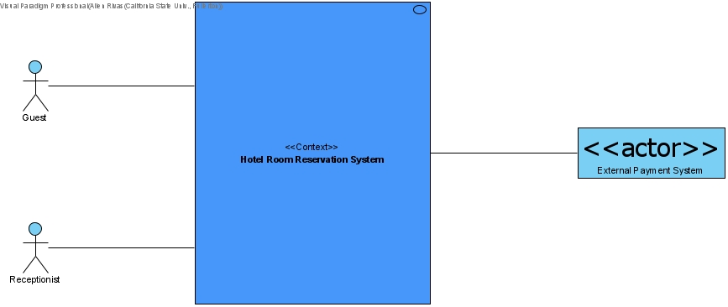

# Summary of Benefits

| Supporting Feature | Stakeholder Benefit |
| --- | --- |
| Functionality, the system will provide all the common services that is required, like reservation authorization, processing payment information and generating a daily/monthly/yearly report. | Automated, fast services |

# Summary of System Features

* Online Reservation
* Payment authorization (credit and debit)
* Generate report that provides information of each user that has reserved at the hotel given certain times of the day, month, or year.

# Investment Summary

## Cost Summary

The price to build/develop will be affordable. The cost to develop the software will be around $600,000. It will also need to go under testing which will be another $100,000 because we want to provide a software that works, but also it is reliable. To maintain the yearly updates of this software would be a yearly cost of around $50,000. The total cost of this project will be $750,000.

## Pricing Summary

The retail price of this product will be $950,000. The idea is to sell the product to hotel companies, and expand not just into one specific branch, but into others. For the companies who buy our software will need to pay for the yearly updates of $50,000. The resulting revenue is about $250,000 per sale. We do have an idea which could possibly expanding the product into a subscription. Where hotels who are interested can have a monthly subscription between $20,000-50,000. There three different tiers. Tier 1 is the $50,000, this is for companies who want full use our hotel room reservation system. Tier 2 is the $35,000, this is for companies who want to implement their existing system with ours. Tier 3 is the $20,000, this is for companies who are interested in using our full hotel room reservation system, but there are limitations to the system. The yearly updates mentioned before are already included in the subscription. We hope this subscription services makes a revenue of $240,000-600,000.

## Schedule Summary

The schedule that it would take to complete this product would be around 9 months. Our goal is developing this product in an agile process, where we build, configure, and test the product enough to the points where it would be time to be released. Our goal is to hopefully not run into any certain risk around the business, technical, resource, or schedule side. If something were to occur, then our product would most likely be push back an additional 3 months for a total of 12 months to completely have the product fully developed.

### Iteration Plan

High-level schedule showing milestones and proposed features for each iteration for the entire project

| Timeline (dates) | Phase / Iteration | Features & Use Cases Provided | Constraints / Dependencies | Degree of Freedom / Alternatives |
| --- | --- | --- | --- | --- |
| March 23, 2021 | Inception | Vision and Business Case  Risk List and Risk Management Plan  Use-Case Model  Use-Case Model Annex 1  Use-Case Model Annex 2 | This phase is mainly about documentation. Understanding the vision and business. Also, understanding the risks of this project and to understand how use-cases work.  Understanding the risks of a project and to help get familiar with fully dressed use-cases. | To help deciding on a Go/No-Go decision based on the documentation. For this project it will always be a go. |

# Assumptions and Dependencies

* Guest/User has an active Internet Connection or has access to one for reservations.
* Guest/User runs an operating system which supports Internet.

# Go / No-Go Decision

After completing this documentation and understanding the situation with the available resources we decided to, Go.